Week of 9/29/25 - Rental Housing Resource Center
Studio/ 1 Bedroom
Address | Rent Amount | Contact Information | Agency Name | Photos/ Notes
739 S 24th St - Lower Front of front building | $600 | (414) 643-5635 | Affordable Rental Associates | Studio
1040 E. Knapp St. Milwaukee, WI 53202 | $810 | (414) 877-2030 | Dominion Properties | Studio  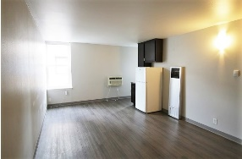
711 W. Wisconsin Ave.  Milwaukee, WI 53233 | $850 | (414) 439-7049 | Bieck Management, Inc. | 1 Bedroom  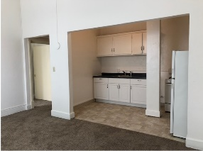
2621 N. Frederick Ave  Milwaukee, WI 53211 | $945 | (414) 248-8766 | Bieck Management, Inc. | 1 Bedroom  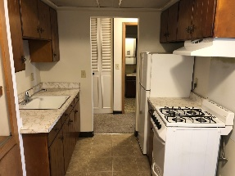
315 North 95th Street #148 | $995 | (414) 801-3307 | Dynamic Property Management | 1 Bedroom  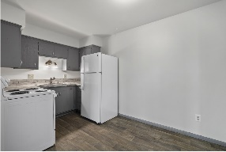

2 Bedrooms
Address | Rent Amount | Contact Information | Agency Name | Photos/ Notes
505 W Maple St - Upper Rear | $800 | (414) 643-5635 | Affordable Rental Associates, LLC
2322 N 53rd st, Milwaukee, WI 53210 | $845 | (262) 269-7112 | Ardell Property Management | 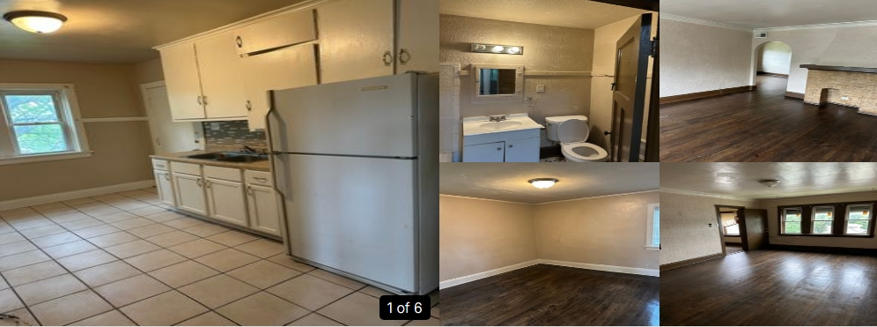
1405 W Oklahoma Ave #3 | $1250 | (414) 551-1377 | Bartsch Management, LLC | 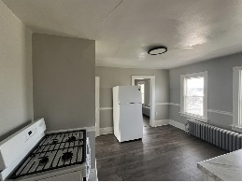

3+ Bedrooms
Address | Rent Amount | Contact Information | Agency Name | Photos/ Notes
769 W. Windlake Ave., Upper, Milwaukee, WI 53204 | $995 | (414) 269-6446 | Citywide Rentals & Property Management LLC | 3 Bedroom  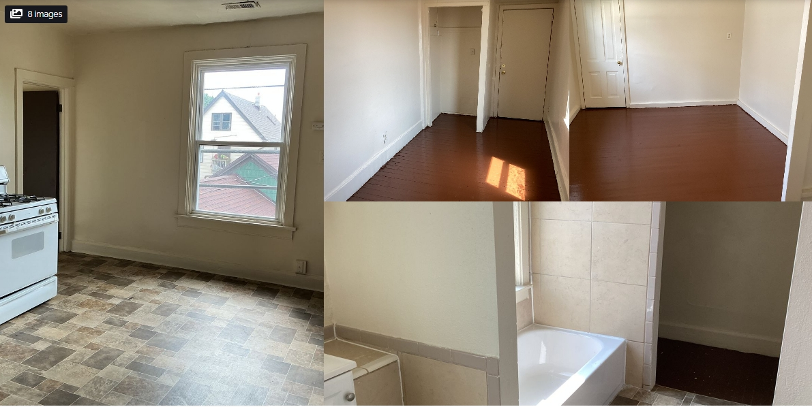
5304- A N. 34th St. - Upper, Milwaukee, WI 53209 | $1,095 | (414) 269-6446 | Citywide Rentals & Property Management LLC | 3 Bedroom  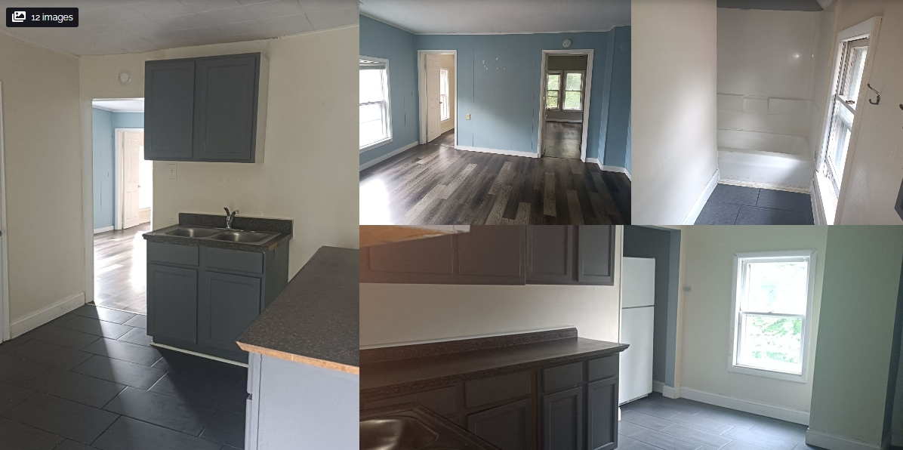
5066 N. 84th Street, Milwaukee, WI 53224 | $1,100 | (262) 373-1777 | Elite Properties, Inc. | 3 Bedroom  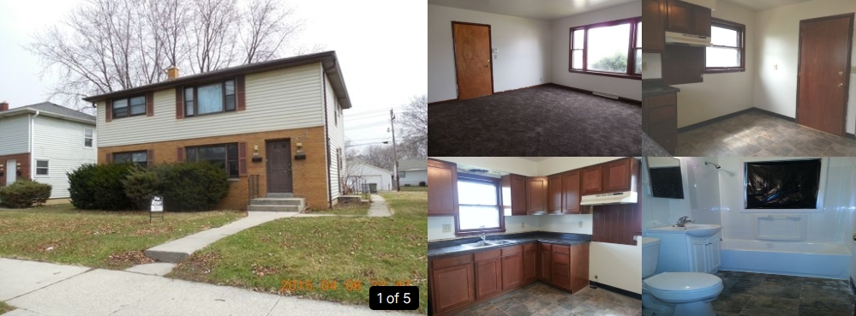
3220A W Greenfield Ave. , Milwaukee, WI 53215 | $1,450 | (414) 460-3279 | Smart Asset Management LLC | 4 Bedroom  